CLOUD COMPUTING
SUBMITTED BY: ARMEEN ABID (BSE-011)
SUBMITTED TO: ENGR.MUHAMMAD SHOAIB
LAB 10
TASK 1:
GitHub CLI + Codespace Setup
Install GitHub CLI
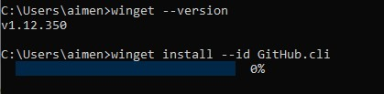
Authenticate GitHub CLI:
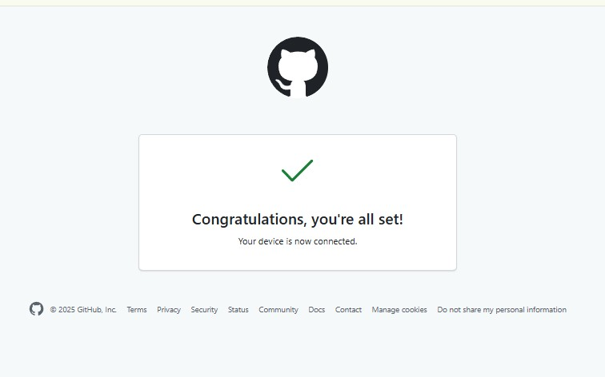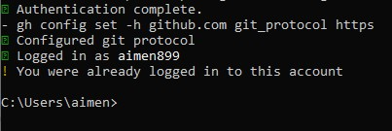

List Codespaces
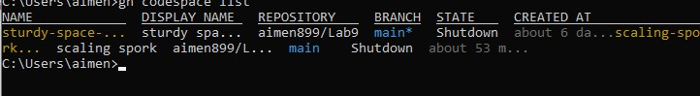

Connect to Codespace
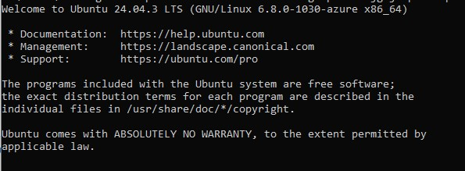

TASK 2:
Install AWS CLI, Terraform, Provider Setup
Install AWS CLI inside Codespace
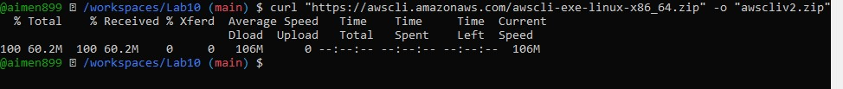

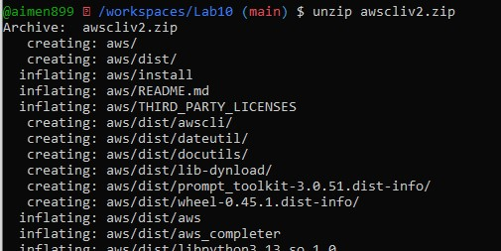

Configure AWS
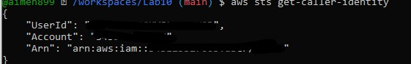
Install Terraform
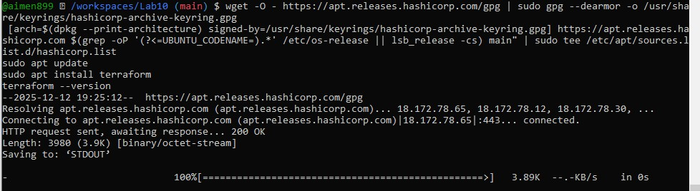

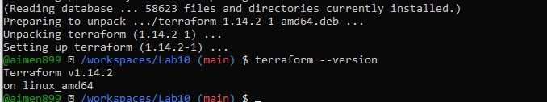

Create main.tf file
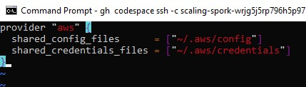

Terraform init
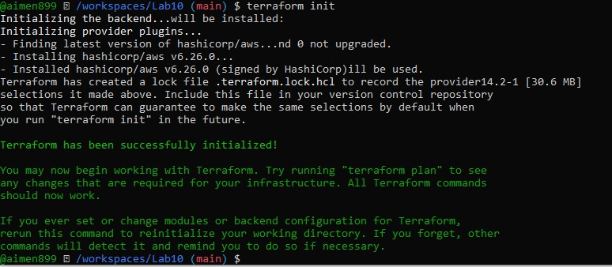
Check terraform files
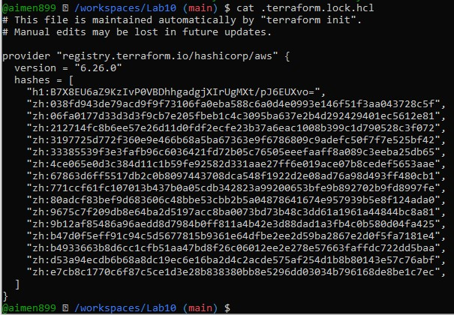
TASK 3:
Create VPC + Subnet, Verify Using AWS CLI
Edit main.tf and add resources
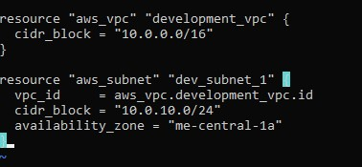

Apply Terraform
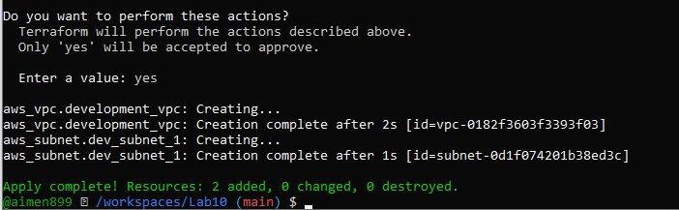

Verify Subnet
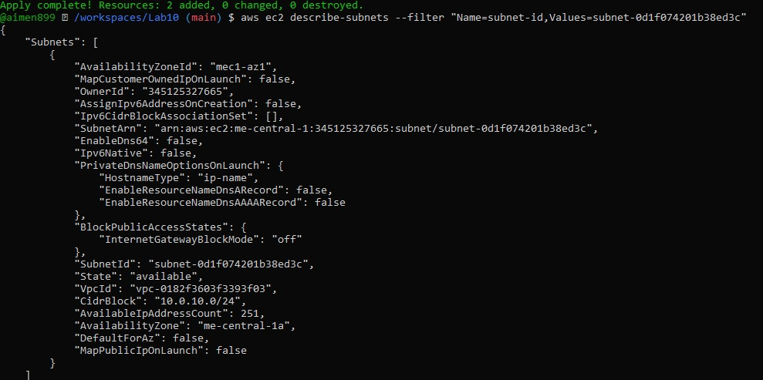
Verify VPC
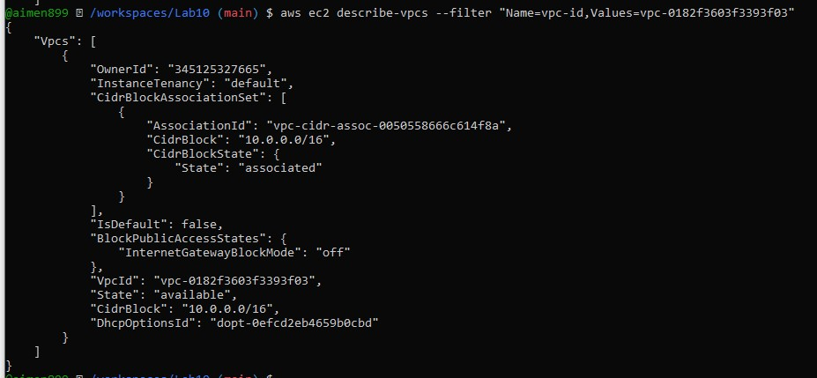

TASK 4:

Data Source, Targeted Destroy, Tagging
Add data source + new subnet
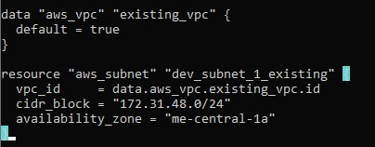
Apply
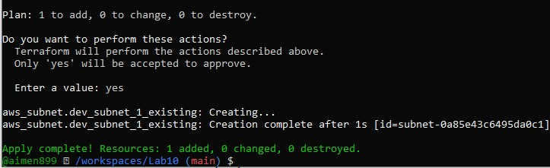

Destroy only ONE resource
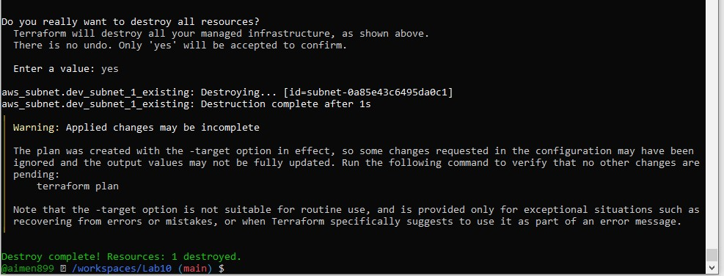

Refresh state
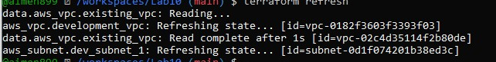

Apply Again
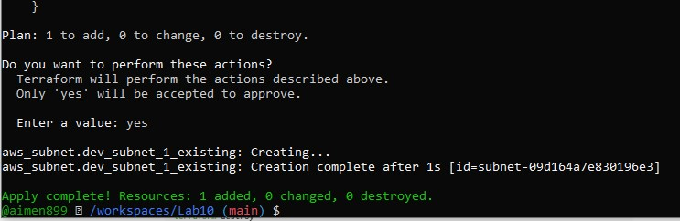

Destroy ALL resources
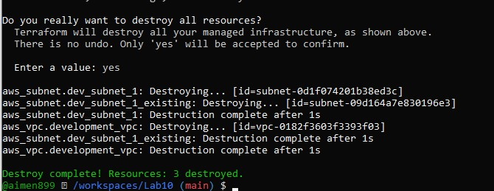
Terraform Plan
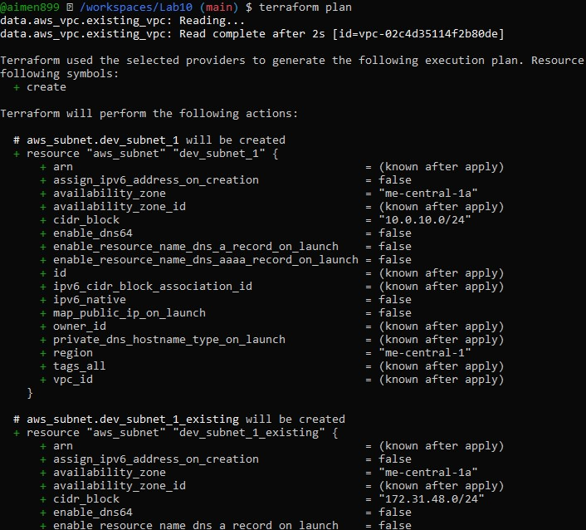
Apply again
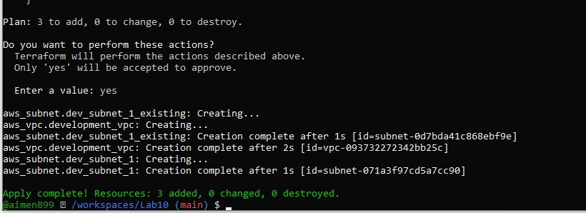

Add tags to resources
Edit main.tf → add under each resource:
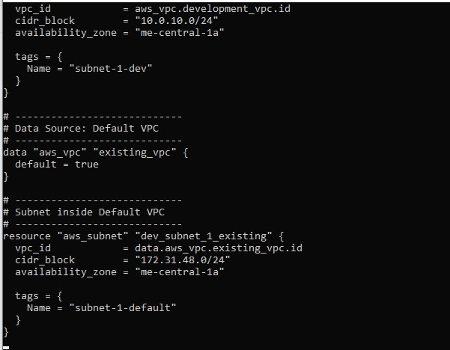
Apply
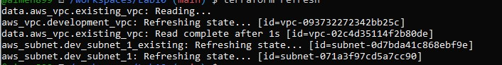

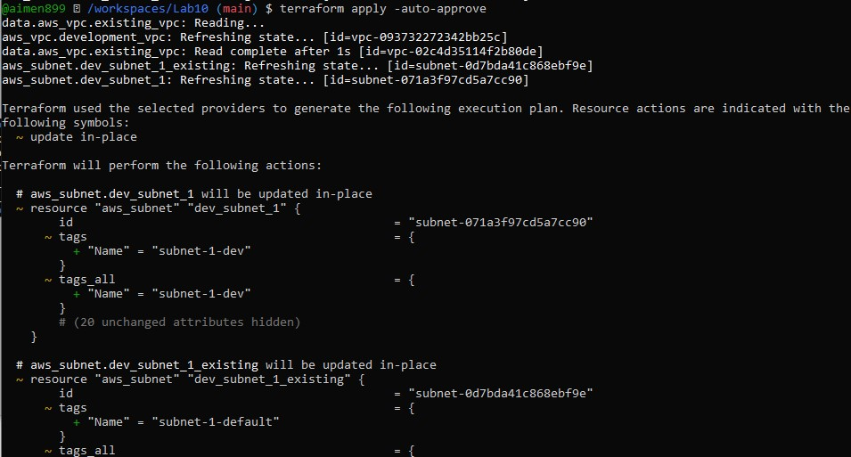

Remove tag & reapply
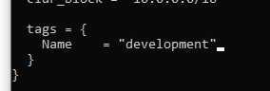

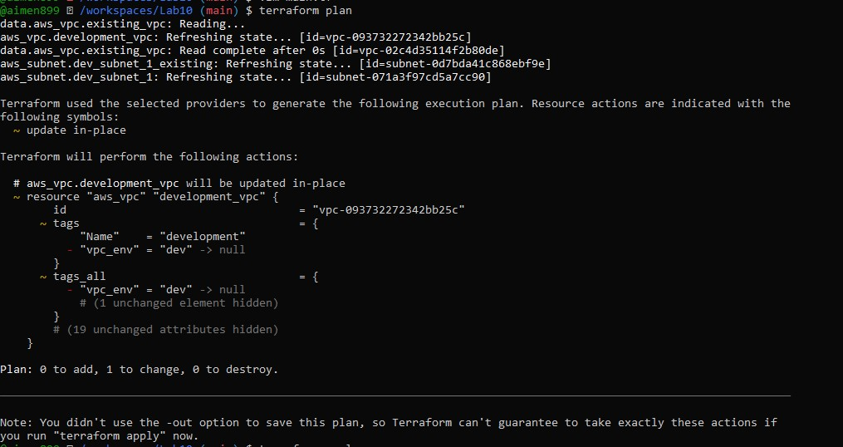

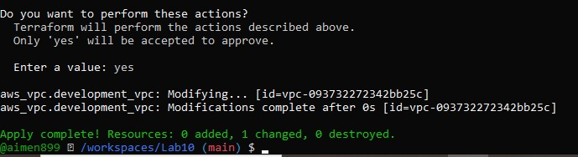

TASK 5:

State File Inspection
Destroy all resources
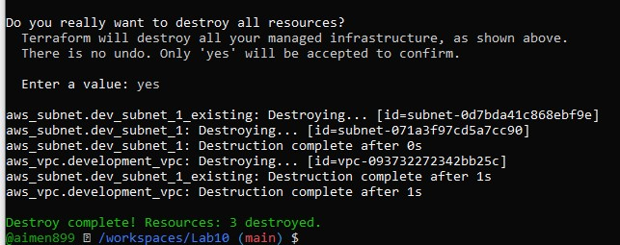

Check empty state
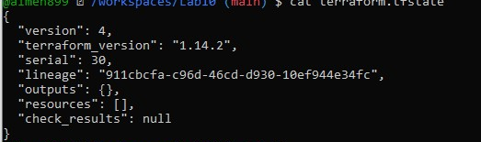

Check backup file
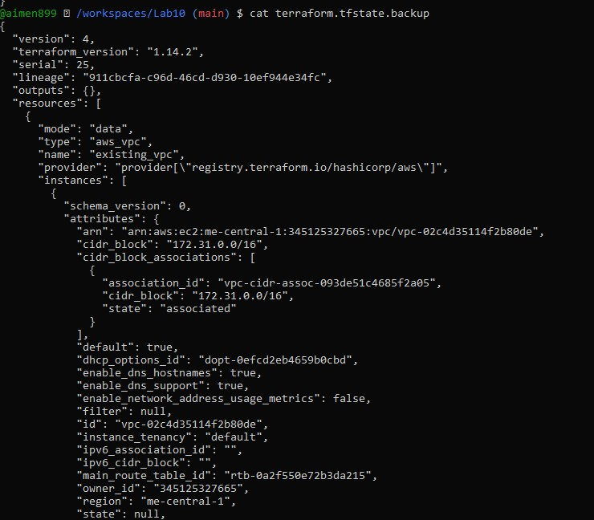

Recreate resources
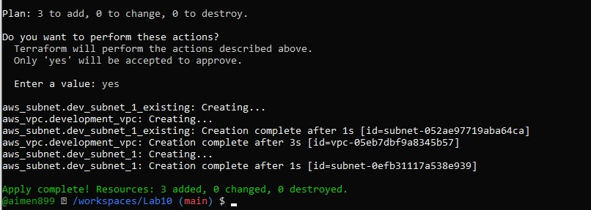

Check state again
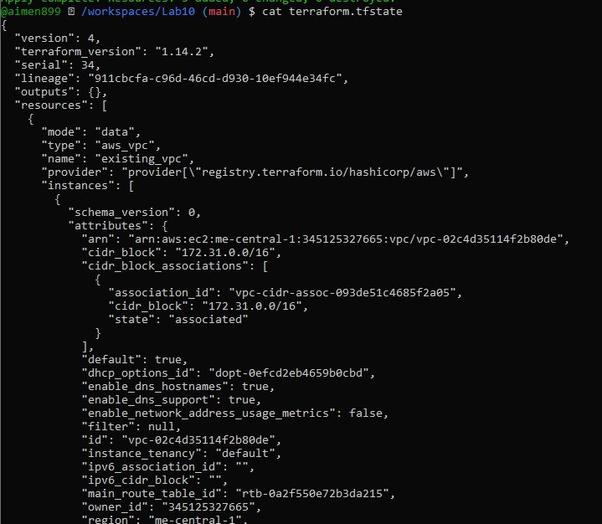

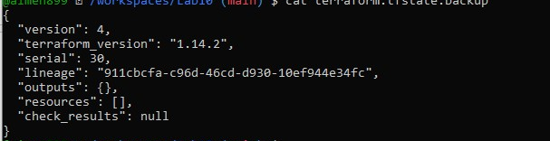

List resources
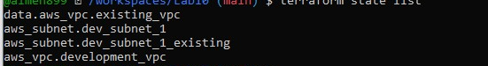

Show attributes of one resource
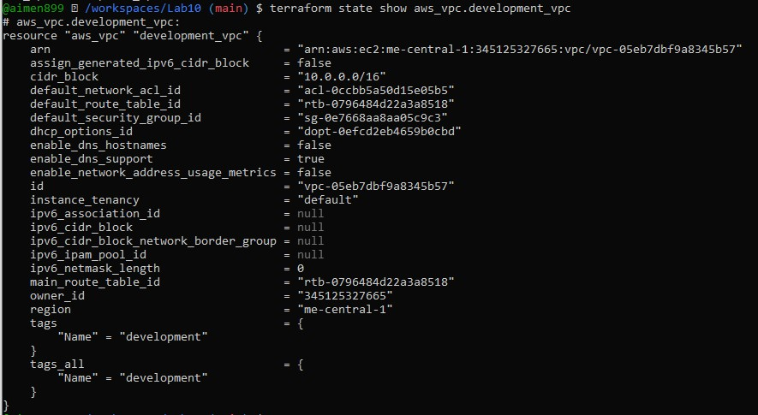

TASK 6:

Outputs
Add basic outputs
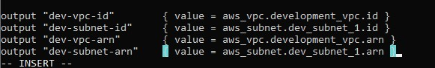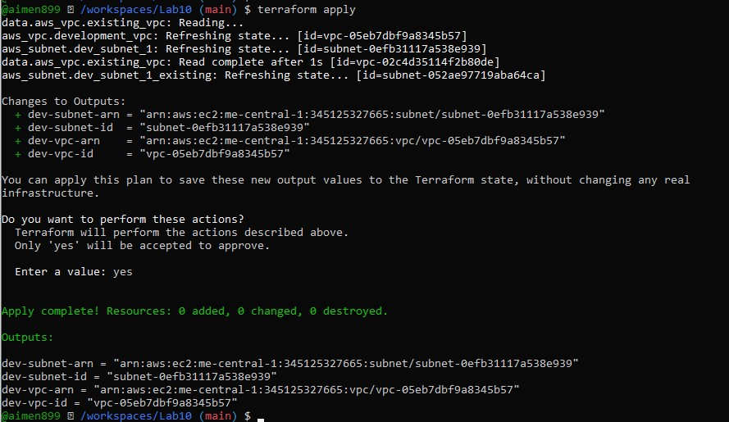

Add expanded outputs
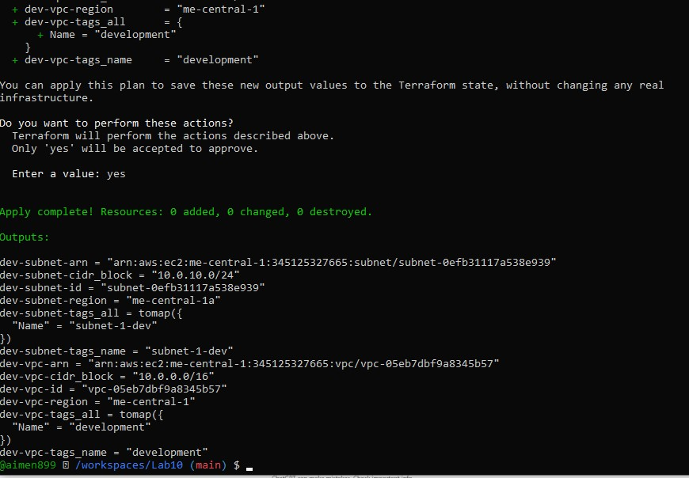

Cleanup the resources:
Destroy everything
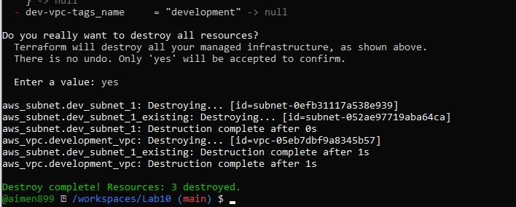

Check final state
